**Facebook App**

**Uri Shapira 201465234 Aline Guetta 000802480**

1. **Features in our application:**

|  |  |  |  |
| --- | --- | --- | --- |
| Type | Feature Name | Description | In the code |
| New feature | Most Liked Photo | A feature which loops through all of the user's photos and finds the one with the most likes and shows it to the user | FacebookAppLogic =>  MostLikedPhotoFilter  In UI –  ButtonMostLikedPic |
| Closest Friends | A feature which shows the user the friends that are also in the user's "Location" | FacebookAppLogic =>  ClosestFriendsFilter  In UI –  ButtonFriendsNextToYou |
| Closest Events | Shows to the user all of the events from his friends that are happening in his hometown or in his location (based on his choice) | FacebookAppLogic =>  ClosestEventsFilter  In UI –  ButtonClosestEvents |
| Friendly Statistics | Opens up a new form which shows to the user various statistics regarding his friends: partition to genders, which friends have his same birthday, the most common religion, and which city most friends live in | FacebookAppLogic =>  CommonReligionStatistics/  GenderStatistics/  HometownStatistics/  BirthdayStatistics  In UI ->  ButtonFriendStats –  All options within Friendly StatsForm |
| Standard Features | Friends list | Gives the user a list of all of his friends | FacebookAppLogic =>  FriendsListFilter  In UI ->  ButtonShowAllFriends |

1. 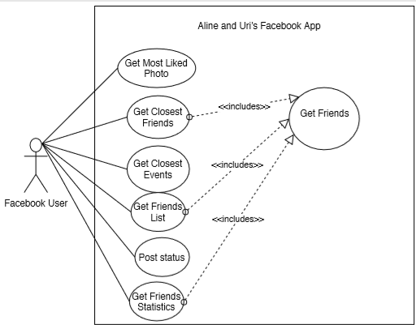**Use Case Diagram:**
2. 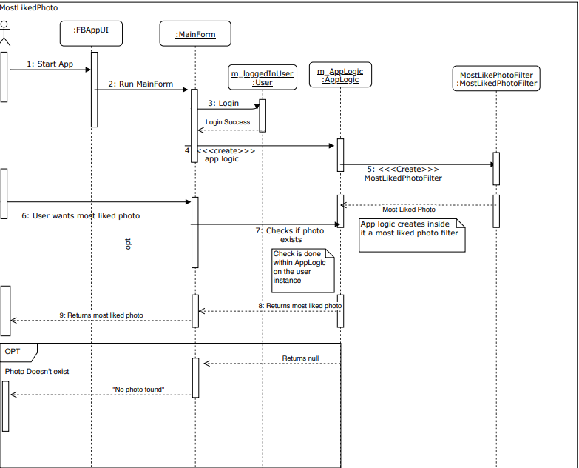**Most Liked Photo Sequence Diagram:**
3. 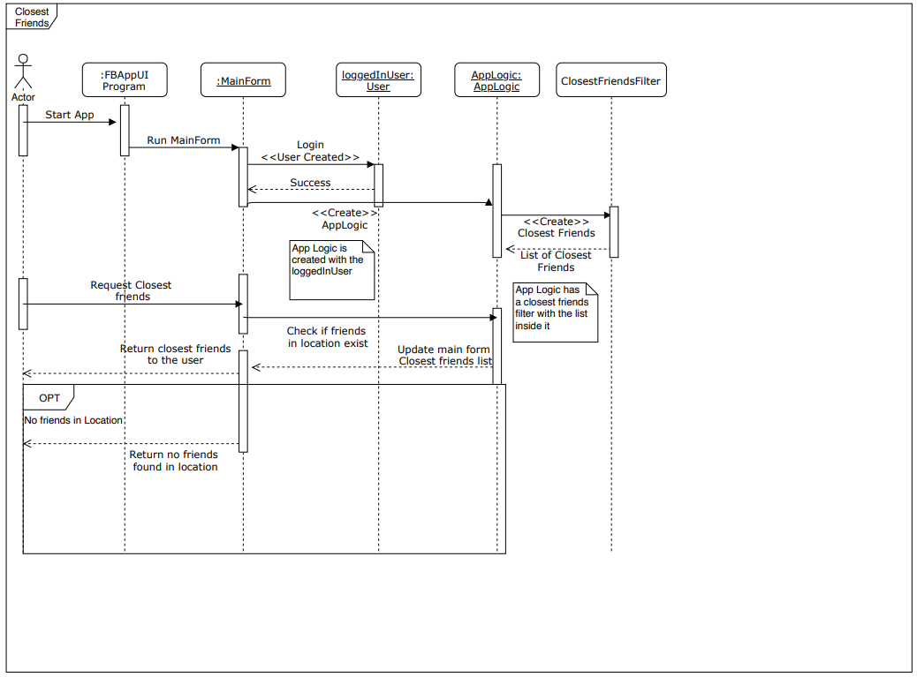**Closest Friends Sequence Diagram:**
4. 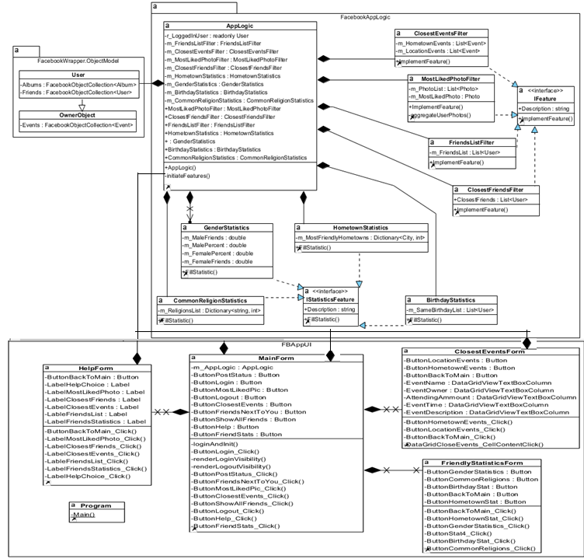**Class Diagrams:**